Up in Smoke By Susan Kallander and Larry Boomgaarden
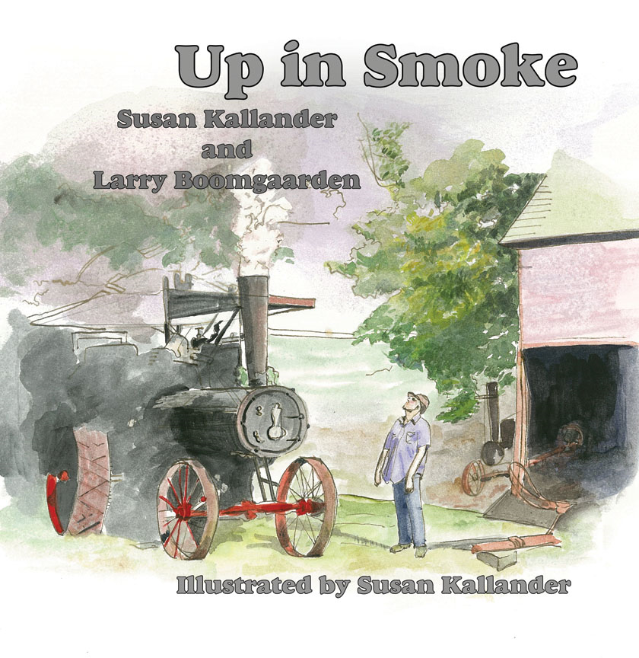
If you’ve ever wondered what it was like to live in “the good old days,” join this family reunion that is held every few years in Minnesota to harvest oats on the family farm. All the chores are accomplished in the same way they were done in the days of their grandparents and great grandparents.
Up in Smoke is a children’s book about one August reunion, as told through the eyes of a child. Fun games and farm animals keep the children busy, while their parents do the threshing with steam tractors. Everybody loves the wonderful farm-fresh food prepared for the 200 participants as well as the evening dances, where music is provided by the family band.
Everyone is sad when it’s time to pack up and leave. This book is a snapshot of a loving family get-together that creates memories for a lifetime.

Meet the Authors
Authors Susan Kallander and Larry Boomgaarden share their memories of Americana. Susan is a New Englander of Swedish descent who recently married into Larry’s Midwestern family. When he asked her to write and illustrate a story about his special family reunions held in Southern Minnesota, Susan agreed. She wanted to create a children’s book with old-fashioned values. Her illustrations for the book are done in watercolor. A graduate of Massachusetts College of Art, her paintings are on display at The Socher Gallery in Connecticut and online at Kallander Art Gallery. The couple sold their home in Massachusetts and now live and travel the United States in a motor home.
View the Press Release

